DELIVER™

TDG - Test Data Generator Functional Requirement Document
Document History

Document Modification History

Version | Status | Date Modified  (DD/MM/YYYY) | Modified by | Remarks
0.1 | Draft | 19/11/15 | Capgemini TDM Team

Document Author, Reviewers and Approvers

Description | Name | Role
Document Author | Capgemini TDM Team
Document Owner
Document Reviewers
Document Approvers

Document Sign-off

Name | Role | Date (DD/MM/YYYY) | Sign

Copyright © 2014 Capgemini

TABLE OF CONTENTS
1. Introduction 4
1.1. Objective 4
1.2. Purpose 4
1.3. Business Drivers 4
1.3.1 Proposed System 4
2. Project Scope 5
2.1. In Scope Functionality 5
2.2. Out of Scope Functionality 5
3. Requirements 5
3.1. UI Requirements 5
3.2. Functional Requirements 7
3.3. Database Requirements 9
4. Flow Diagrams 10

Introduction

  - Objective
Testing a data- conscious application is one of the most important but time consuming tasks. It is always important to test any application with REAL data. To fill your database with test data, you need a generator. Test data Generator is the tool through which user can easily generate realistic data based on the column characteristics and or based on what the user defines. Currently, database developers and administrators often have to spend hours of dull work to create test data sets before examining database or application performance. TDG makes all this unnecessary by automatically creating database data.

  - Purpose

The purpose of this document is to describe the overall requirements for Test Data Generator (TDG), a component of TDM Central (Test data Automation) tool to fulfil the following needs of test data management process.
  - System Drives
When developing an application, you would be wise to test it. You might test it for correctness and you might test it for load. Both of these situations benefit from having a large body of data that is semi-coherent but that is automatically generated. Manually inserting 3 or 4 rows in each table just isn't good enough. This is taking big challenge to testing team or development team to provide the data in database. We have currently manually upload the excel, csv...etc documents into some CRM or batch processing jobs to inject the data into database. Here once again we will face the problem of referential integrity. This has been making big problem in current application which has been developed.
    - Proposed System
TDG will be catering solved problems which are facing current test teams. This tool will generate the realistic (synthetic) data as well as referential integrity by default. And also has support for different business rules problems while generation the data, Regex support, column concatenation...etc.

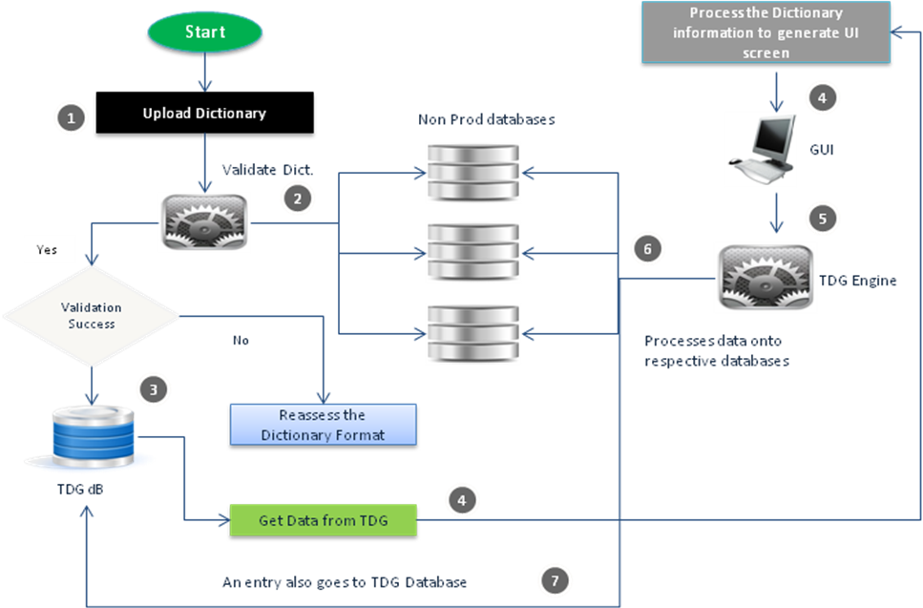

Project Scope
The main scope of project is to generate the data in different database like with referential integrity support.
2.1 In Scope Functionality
TDG will be given support of following databases to connect directly
- Oracle
- Mysql
- SQLServer
- DB2
- Postgres
2.2 Out of Scope Functionality
TDG doesn’t provide followed platforms to connect directly
- MongoDB
- Cloud related databases
- Mainframes

Low Level Requirements

UI Requirements

Requirement ID | Requirement Description | Priority | Complexity  S/M/C
BR01 | Login Page  - User should be asked to provide User Id and Password  - There should be option for user to reset password using ‘Forgot Password’ Option.  - Incorporate all the functionalities of a Login page in general. | High | C
BR02 | Logical Data Generation  TDG has three tabs :  - Admin  - User Management  - Application Configuration Management  - Services  - Test Data Generation  - Dashboard  - Training  - Manual  - Videos  User Management :  - Add User  - Modify User  - Remove User  - Change Password  Application Configuration Management :  - Upload TDG Dictionary  - TDG Dictionary Dashboard  Definitions:  - Master Dictionary: This is nothing but properties file, which contains test cases related columns of target database. It has some predefined keywords like schme_name, Schema_url…etc  - 2. Manual Dictionary: This will contains the demographic values with respective to columns names. | High | C
BR03 | - User, Who are having admin rights they should have link upload TDG dictionary and allow to support “.properties” type file.  - There should be a “upload” inline button. Once user click on this button popup should open to attach a file.  - There should be a “Submit” to upload the master dictionary.  - The result should display inline message on same page whether its success or failed.  - Demographic values should be uploaded once master dictionary got upload.  - Once master dictionary get uploaded a hyper link should be there on master dictionary name. If user will click on that, then popup should be open to upload the manual dictionary. Popup should have upload button in inline “text box” and “submit” button should be there.  If this master dictionary has manual dictionary and manual dictionary columns name are also exist in master dictionary then one “checkbox” should display in respective GUI component.
BR04 | User can trace the request from dashboard.  - This page should have one “text box” and “submit” button.  - Once user enters the request id and submits the request. Search result should display in grid. | High | C

Functional Requirements

Test Data Generator Functional Requirements

Requirement ID | Requirement Description | Priority | Complexity  S/M/C
BR04 | TDG engine will be catered different databases support SQL, MYSQL, DB2, and ORACLE. Firstly target to Oracle DB only. | High | C
BR05 | - Master dictionary configuration analyzes and templates design.  - Master dictionary should have proper TDG reserved keywords.  - Master dictionary should have TDG logic GUI generation components (Textbox, Radio, Checkbox…). | High | C
BR06 | All the tabs should be displayed in one row with respective to master dictionary display. | Medium | M
BR07 | Master dictionary defined GUI components will get display in dynamic format. | Medium | M
BR08 | “Checkbox” should display if master dictionary and manual dictionary has same column names. User can select either manual dictionary values by “check” or else user may enter the required values. | Medium | M
BR09 | Master dictionary should have to support up to 50 columns in GUI level. | High | C
BR10 | - Each tab should display what database type of this tab. This should be populated dynamically by TDG engine while rendering the master dictionary.  - Tab should have generated count component where user can enter the required data generation count.  - Once user entered the required values, submit the tab values. Later whether it success or failed should be display via popup with request id(which will be used to trace the history of data generation in dashboard). | High | C
BR11 | Dash Board Result display should be ‘Sortable’. If data generation will get success then result grid should have “dropdown” to download the GUI related values (which has been generated or submitted by user) and result should be in pagination format. | Medium | M

ADMIN Functionality Requirements

Requirement ID | Requirement Description | Priority | Complexity  S/M/C
BR12 | Admin would have the access to add new users as explained TDM Central. | High | C

Auto Email Functionality Requirements

Requirement ID | Requirement Description | Priority | Complexity  S/M/C
BR13 | In TDG, If data got generated then email should be send to user. | High | C

Dash Board Data Download

Requirement ID | Requirement Description | Priority | Complexity  S/M/C
BR14 | User should have the option to download the respective generated results in .xls/.csv/.pdf format. | High | C

Database Requirements

Requirement ID | Requirement Description | Priority | Complexity  S/M/C
BR15 | Database used will be ORACLE DB and should have two schema’s will be Users, TDG dictionaries related. | High | C

Flow Diagrams 